# Why Responsive

1. Motivation behind responsive design:
   1. Make websites to work for all devices
2. Devices emulator for web developers:
   1. 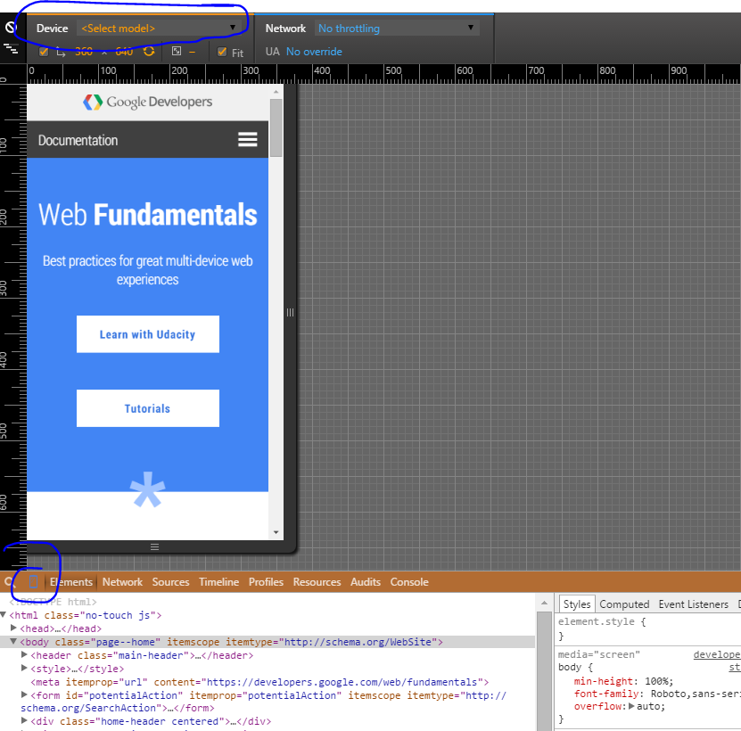
3. 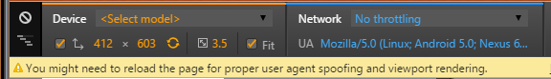
   1. UA: user agent
4. Use dev tools on mobile:
   1. [Download and install Chrome Canary](http://www.google.com/intl/en/chrome/browser/canary.html)
   2. Enable debugging mode in your mobile phone
   3. Go to canary and type chrome://inspect
   4. You should see the device
   5. You can inspect webpages running mobile devices through your desktop
   6. You can also show the mobile view on your desktop:
      1. 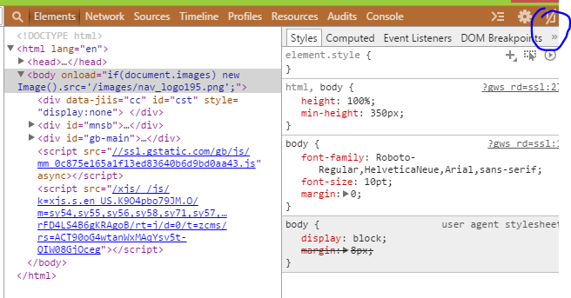

# Defining the Viewport

1. Viewport defines the area of screen the browser can render contents to.
   1. Pixel density
   2. Dip:
      1. Device independent pixel, relate pixel to distance,
2. No meta viewport:
   1. It assumes that the browser render the webpage on 980dip
3. Css pixels = dip
4. Pixels-related questions:
   1. 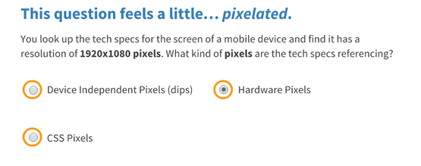
   2. Device ratio pixel = pixel/dip
      1. 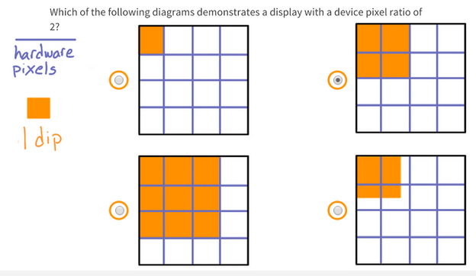
   3. 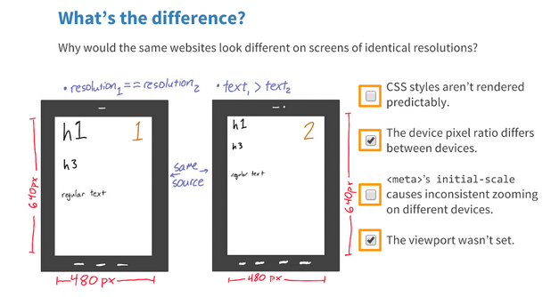
   4. 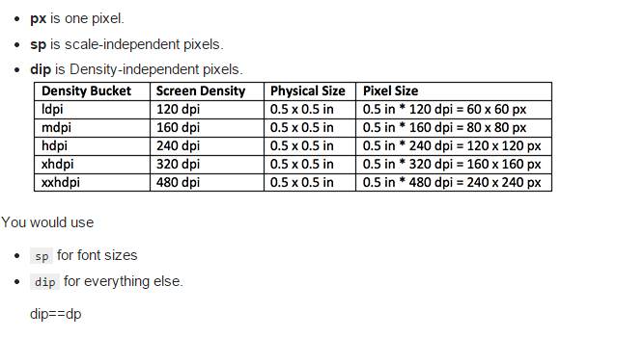
   5. 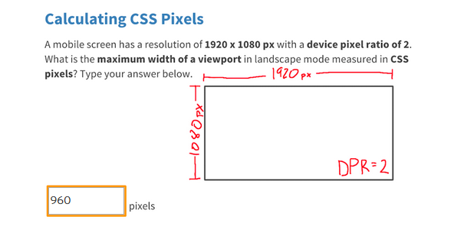
      1. Css pixels = dip
   6. 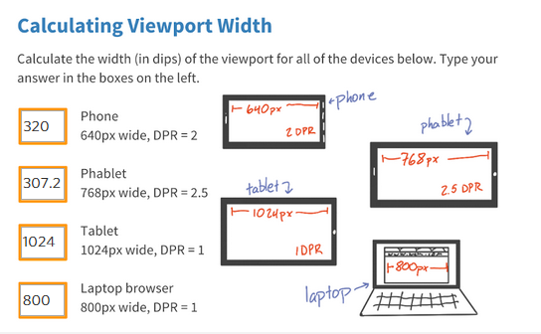
5. Viewport are defined by dip
6. Add meta viewport:
   1. 
      1. Device-wdith unit is dip
      2. Initial-scale = 1🡺 1 css pixel = 1 dip
7. Relative position should be used
   1. 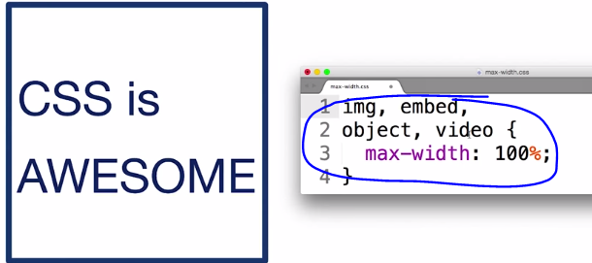
   2. Good practice to make sure the content will flow the container
8. Buttons:
   1. 48px x 48px
   2. 
9. Start small for design
   1. Starting from small 🡺 prioritize content
   2. Performance
10. 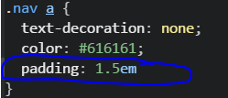
    1. 1.5em means that the padding is the 1.5 size of the font
11. Build a webpage for mobile:
    1. 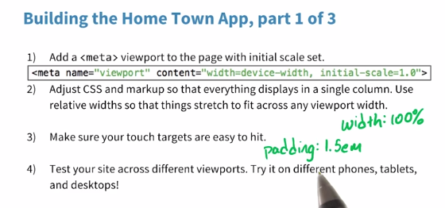

# Building up

1. A responsive site change for different devices
2. Selective CSS
   1. Media queries
   2. 
   3. 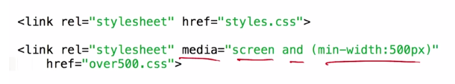
      1. Just stick with screen and print